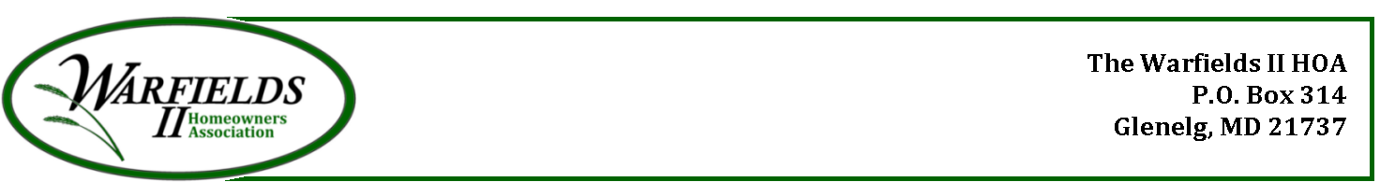

Warfields II HOA – Covenant Meeting
March, 27, 6:15PM
Meeting Minutes

Meeting Purpose: All member meeting to discuss proposed new covenants including Lisa Heimlicher, Esq who prepared new document

Call to Order (6:15PM)

- Asked if fireworks are permitted by HOA. Nothing in covenants about fireworks. Since most are illegal, neighbors should call police to report crime.
- Quiet hours are proposed in new covenants for which neighbors can call on HOA to intervene.
- Asked for comparison of old and new covenants. Expressed email listing differences was not detailed enough.
- Asked why amendment removing easement and black fence in 2T area was not included in new covenants. That amendment was not found in Land Records. Ron Wilcom will get a copy to Board and attorney.
- Asked if covenants clearly state that HOA will continue snow removal on shared driveways. That is the intention and will make sure it’s included in covenants.
- Asked if sign could be placed on Howard Rd indicating home numbers of homes on shared driveway. Ujuhal will send us a photo of possible signage.
- Asked about maintaining forest conservation and graveyard.
- Complaint registered that neighbor receives ‘no services’ from HOA so wonders why he should contribute.
- Proposal for different way forward starting with survey of neighbors to gauge interest in changing from Board going onto properties to make repairs vs fining properties which are not in compliance.
- Expressed that old covenants have more teeth than fining. Conversely, no one on the Board or previous was willing to take that action against neighbor. And unlikely any contractor would either.
- Suggestion to put contact info of landscapers, painters in warning letters in case owner needed help.
- Asked if there is provision in covenants that Board must notify neighbor when going on their property.
- Expressed that changes in 2.9 are too strict regarding bushes.
- Expressed that removing/placing trees is too strict
- Explained that neighbors can overrule Board decision by ⅔ vote.
- Vote by hands in favor of sending out comparison of old and new covenants along with survey of interest in fining vs Board changing property. Near unanimous approval.

Meeting adjourned 8:15

